**Profile Building Assignment**

1. What is the difference between UI and UX? Explain in your own words.

Ans - UI stands for User Interface,it includes all the things which are present on the websites, the designs and basically how the website will look , this design is then given to the front end developer so he/she can implement it properly.

UX stands for user experience, it basically includes how the user and websites interact, such as choosing a drop down menu or a check box. The overall using experience for the user should be kept in mind while building a website. Its example includes keeping the payment button of green colour so that the user clearly feels what he is doing and going to make a payment.

2.Who is a front end developer? Explain the roles and responsibilities in your own words.

Ans- Front end developer , in simple words is the person who develops the front end of a website which includes all the things which are displayed to the user and how the user interacts with the site like giving some inputs, and it also includes making requests to the server for a requirement.

3.Who is a back end developer? Explain the roles and responsibilities in your own words.

Ans - Back end developer is the one who manages the website from backend like managing all the databases ,storing the information, responding to a query, etc.

4. Create your own GitHub & LinkedIn accounts. Share the screenshot of both of your accounts and share your profile links of GitHub & LinTedIn in the solution.

GitHub - <https://github.com/HemantNavlani>

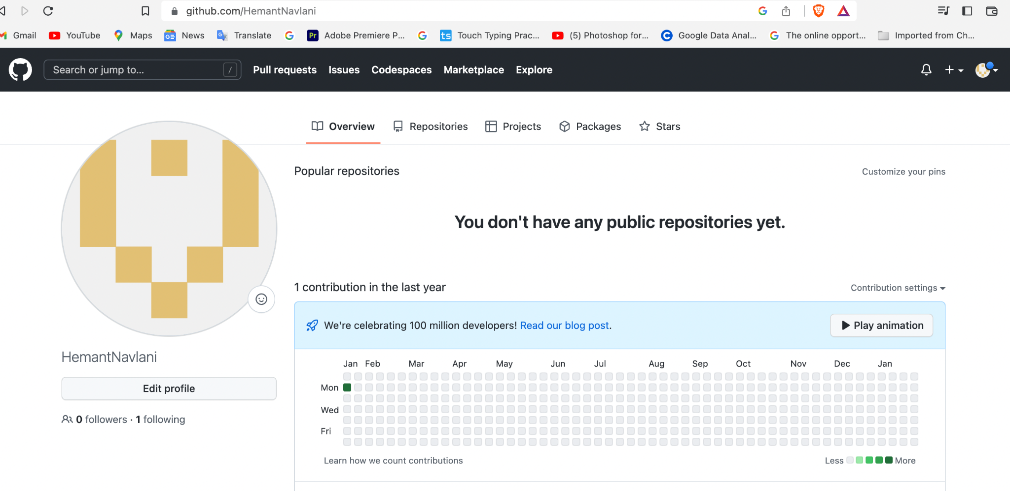

LinkedIn - <https://www.linkedin.com/in/hemant-navlani-1a5a331b4>

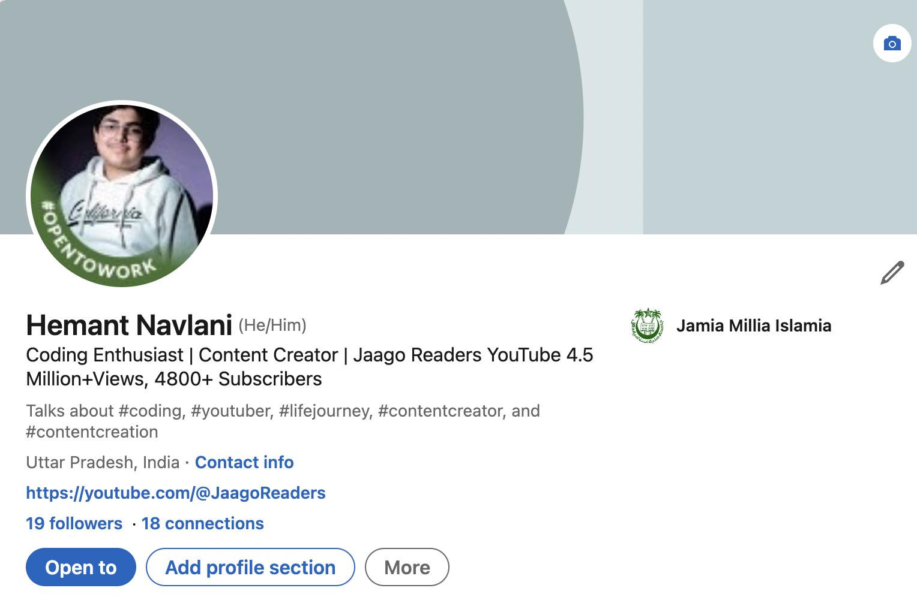

5. Write your first blog on your favourite platform and share the link to the blog. (-you can choose any topic for writing your 1st blog)

First Blog Link -

https://hemantnavlani.hashnode.dev/what-is-coding